OUTPUT:

9a. REGRESSION USING MLP ON BOSTON HOUSE PRICE DATASET

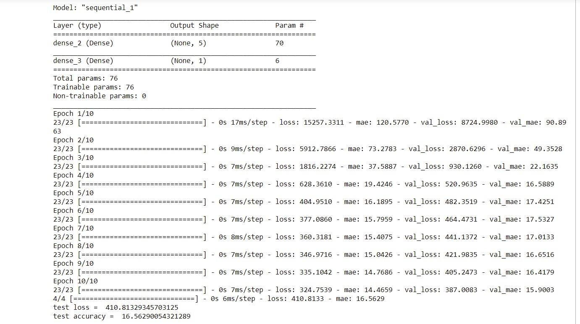

9b.i. MULTI CLASSCLASSIFICATION USING MLP ONLOAD_ IRIS DATASET

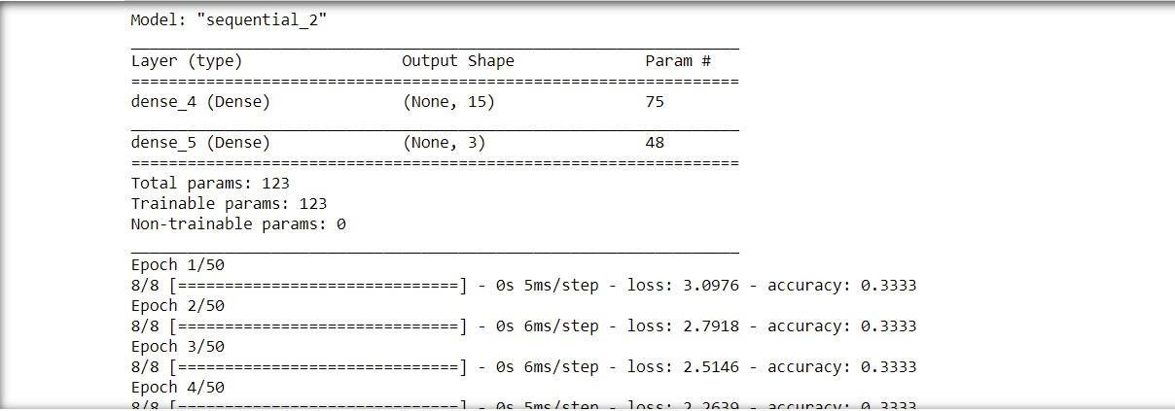

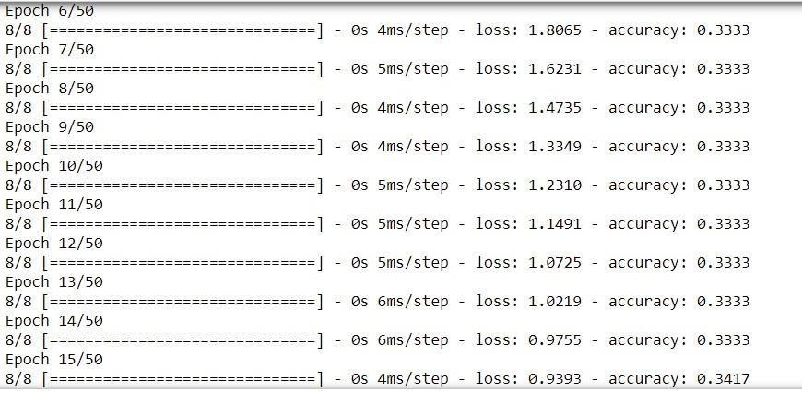

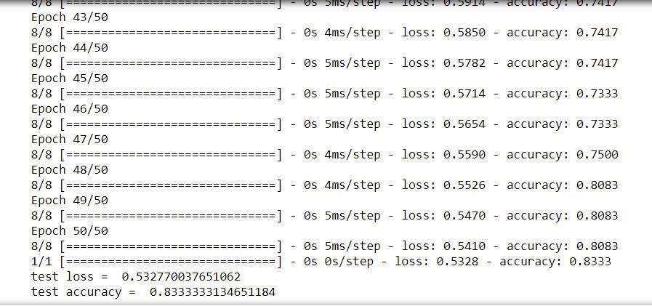

9.b. ii. MULTI CLASS CLASSIFICATION USING MLP ON LOAD_WINE DATASET

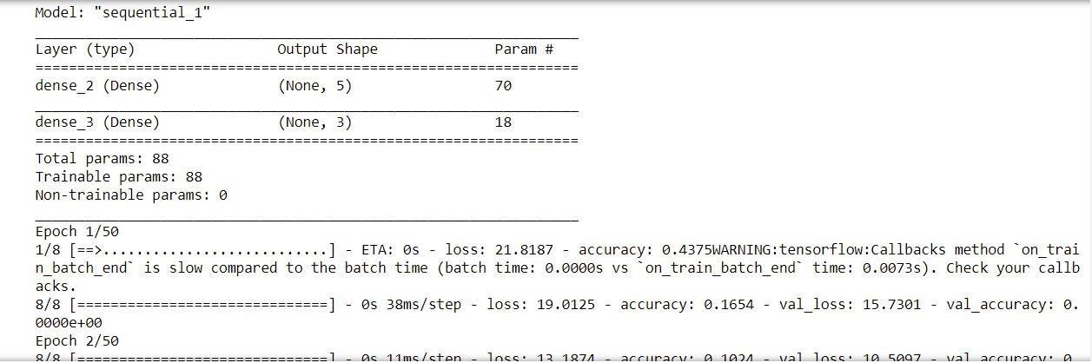

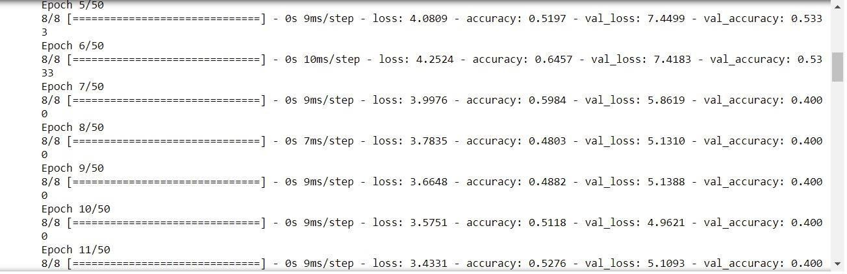

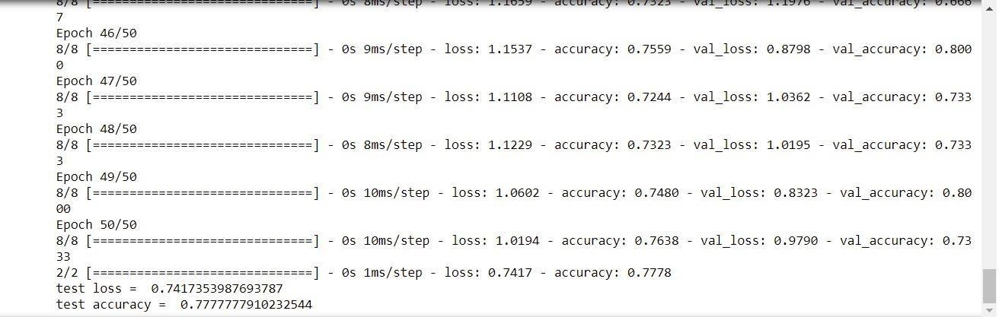

1. iii. MULTI CLASS CLASSIFICATION USING MLP ON FOREST_COVER DATASET

